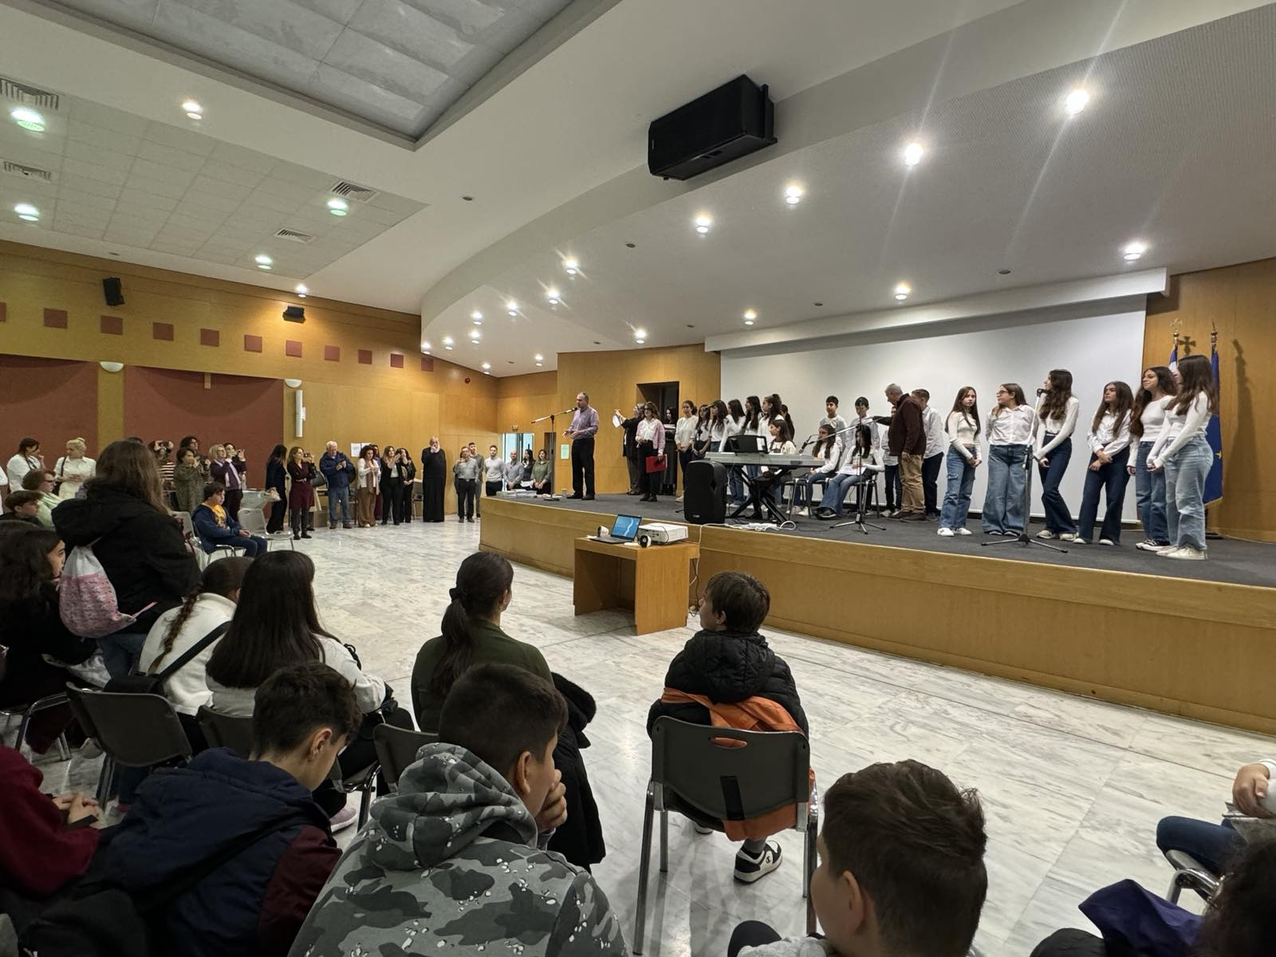
26-11-2024 Educational Program (18-11-2024) “Child Abuse: We React and We Hope”- Experiential Workshops
On Monday, November 18, 2024, the educational program entitled “Child Abuse: We React and We Hope” – Experiential Workshops, co-organized by the General Secretariat for Religious Affairs, the Ecumenical Forum of European Christian Women “Damaris the Athenian,” and the “Initiative for the Prevention of Domestic Violence” of the Youth and Family Foundation of the Holy Archdiocese of Athens, was held at the Ministry of Education, Religious Affairs and Sports.
This educational program was implemented under the Memorandum of Cooperation dated September 4, 2024, between the aforementioned bodies, with the aim to prevent and effectively address child abuse by adults and/or other children.
It consisted of eight concurrent workshops, in which 230 students, accompanied by their teachers, from middle and high schools of Attica and Evia participated.
The workshops were conducted by specialized facilitators from the fields of education, the Theatre of the Day, “The Smile of the Child,” the Greek Police’s Office for combating Domestic Violence, and the Sub-Directorate for the Protection of Minors of Attica.
The choir of the 7th Middle School of Nea Ionia accompanied the event with a song composed specifically for the educational program.
