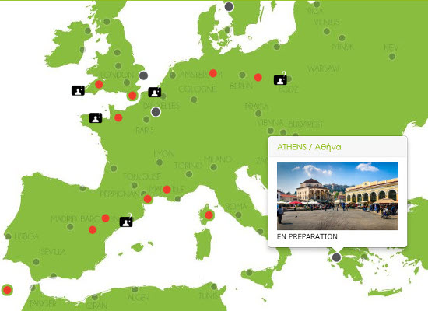

21-12-2018 Initiatives of the General Secretariat for Religious Affairs to Promote Dialogue and Mutual Understanding
The General Secretariat for Religious Affairs, in cooperation with the organization “The Beit,” implemented “The Beit Project” in Athens for the first time.
“The Beit Project” is an educational program promoting social cohesion, which has already been successfully implemented in many European cities. The program, addressed to all levels of education, connects historical heritage with the fight against racism, social exclusion, and discrimination.
By making use of the urban space, students explore the concept of the “other” in society. Students of the same age from different schools build a shared “mobile school” in a public space, where they meet and study together. Inspired by the traces of the present and the past they discover in the city, they discuss various topics, aiming to understand that differences, rather than obstacles, can be advantages.
The pedestrian walkway in Thiseio was selected as the main venue for the program, near Melidoni Street, as it features numerous landmarks highlighting the history of the country and the city, its unique architecture, as well as the coexistence of different religions and cultures (Kerameikos Cemetery, Church of Agioi Asomatoi, Jewish Synagogue, Holocaust Memorial, Centre for the Study of Modern Ceramics, Museum of Islamic Art, among others).
The participating schools included: the 1st Elementary School of Palaio Faliro, the 28th Elementary School of Piraeus, the Jewish Elementary School of Athens, the 2nd and 4th Middle Schools of Elefsina, the Model Middle School of the Evangelical School of Smyrna, the 7th Middle School of Chalandri, the 1st High School of Palaio Faliro, the 6th High School of Nea Smyrni, and the Rizarios Ecclesiastical School.
Significant support for the program was provided by the Ministry of Culture and Sports, the Jewish Community of Athens, and the Unified Special Vocational School of Athens.

