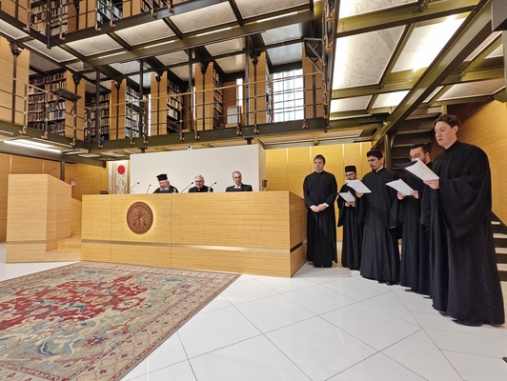
21-11-2024 Signing of a Memorandum of Cooperation between the Apostoliki Diakonia of the Church of Greece, the General Secretariat for Religious Affairs, and the Pontifical Gregorian University
A Memorandum of Cooperation was signed on Friday, November 15, 2024, at the Pontifical Institute of Eastern Studies in Rome, between the Apostoliki Diakonia of the Church of Greece, the General Secretariat for Religious Affairs of the Ministry of Education, Religious Affairs, and Sports, and the Pontifical Gregorian University.
The Apostoliki Diakonia of the Church of Greece was represented by its General Director, Metropolitan of Phanar, Mr. Agathangelos; the General Secretariat for Religious Affairs by the Secretary General, Mr. George Kalantzis; and the Pontifical Gregorian University by Rector, Fr. Mark A. Lewis.
Present at the signing were also the Metropolitan of Italy and Exarch of Southern Europe, Mr. Polycarpos, the Archbishop of the Catholics of Athens, Mr. Theodore Kontidis, and the Ambassador of Greece to the Holy See, Ms. Aikaterini-Katia Georgiou.
In the context of the Memorandum, it was agreed to establish a Department for the Teaching of Byzantine Music, to continue the Modern Greek Language Teaching Program at the Pontifical Gregorian University, and to implement educational and cultural programs among the contracting parties.
Following the signing of the Memorandum, the Secretary General for Religious Affairs stated: “There is no Europe without the Greek and Latin languages. There is no Europe without Christianity. The language of the Gospels and the Church Fathers is Greek. The Byzantine tradition is the tradition of the greatest and longest-lasting European and Christian empire. It is our duty to support every effort that serves these realities.”

