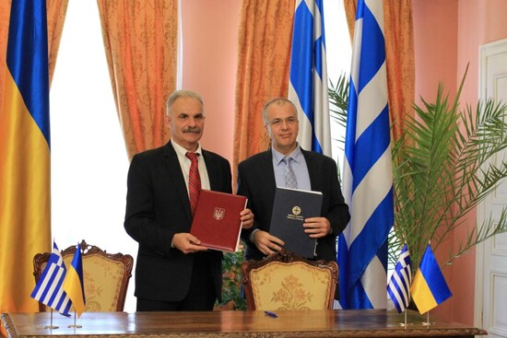
21-06-2025 Greece and Ukraine Strengthen Their Cooperation on Religious and Educational Issues
On Wednesday, June 18, 2025, at the historic Metropolitan’s House located within the emblematic complex of Saint Sophia in Kyiv, the Secretary General for Religious Affairs of the Hellenic Republic, Mr. George Kalantzis, signed a Memorandum of Cooperation and Mutual Understanding with the Head of the Ukrainian Service for Ethnic Policy and Freedom of Conscience, Mr. Viktor Yelensky,
The two governments, taking into account:
- that the Ecumenical Patriarchate of Constantinople is the Center of the Eastern Orthodox Church of Christ and holds a unique role in Orthodoxy as the Mother Church,
- the centuries-old relations between the Greek and Ukrainian peoples, and
- Ukraine’s expressed desire to further develop cultural, educational, and religious cooperation with the Hellenic Republic,
have decided to deepen their collaboration in the following areas:
Academic exchanges of students and professors in theology and the humanities.
Provision of Modern Greek language courses and enrichment of Ukrainian theological libraries with contemporary Greek scholarship.
Institutional partnerships with Theological Schools and Academies in Greece, including joint conferences, summer schools, and other activities.
Specialized pastoral training programs for clergy serving in hospitals and the armed forces.
Specialized pastoral seminars for clergy supporting those affected by the ongoing conflict.
During the signing of the Memorandum, Mr. Yelensky, emphasized that this marks a new and valuable impetus for the development of Theology in Ukraine at a time when people are increasingly turning to religion for answers to existential questions that other sciences cannot address. He stressed the importance of dialogue about how faith is experienced in the 21st century and how the Church responds to this need—especially in a time of war. He warmly thanked the Secretary General for Religious Affairs of the Hellenic Republic for his decision to travel to Kyiv for the signing of the Memorandum.
Mr. Kalantzis, referred to the special spiritual bond between Greeks and Ukrainians, founded in Orthodoxy, and stated that the high moral stance of the Ukrainian people—bravely defending their independence and freedom—serves as an example for the entire world, and particularly for smaller nations facing unjustified aggression from more populous neighboring countries. He also noted that the Memorandum was signed in Kyiv as a minimal yet meaningful gesture of respect and a tangible expression of Greece’s solidarity. Finally, he expressed his hope that peace will soon prevail so that Ukraine may thrive within its internationally recognized borders as a modern European democracy.
The signing ceremony was attended by the Ambassador of the Hellenic Republic to Ukraine, Mr. Pantelis–Alexandros Dimitrakopoulos, the Deputy Head of the Greek Embassy, Mr. Manolis Androulakis, representatives of the Greek community in Ukraine, and representatives of the Autocephalous Orthodox Church of Ukraine.
Following the signing, the Greek delegation and Mr. Yelensky visited His Beatitude Metropolitan Epiphaniy of Kyiv, Primate of the Autocephalous Orthodox Church of Ukraine, at the Holy Monastery of St. Michael.
His Beatitude warmly welcomed the Greek delegation, stating that he received them at the “spiritual center of the Orthodox Church of Ukraine, a place of honor and remembrance for the modern heroes of the Ukrainian nation.” He emphasized that, despite the difficult struggle, the Ukrainian people rightfully seek victory, drawing strength from their unwavering faith, the bravery of their defenders, and the support of friends and international partners.
“We express our sincere gratitude for the solidarity and support of Greece,” the Primate of the Orthodox Church of Ukraine said. “We are especially grateful to His All-Holiness Ecumenical Patriarch Bartholomew for the historic decision to grant the Tomos of Autocephaly. It was a prophetic decision, as the Church plays a pivotal role during wartime in offering spiritual and moral strength to the people. We also warmly thank the Church of Greece, which supported this wise and visionary decision.”
In his response, Mr. Kalantzis, highlighted the unique role of the Ecumenical Patriarchate of Constantinople in Christianity and especially in Orthodoxy, noting that Greece officially recognizes it in its Constitution. He affirmed that the Autocephalous Orthodox Church of Ukraine, as the spiritual mother of the Ukrainian people, supports them effectively and sacrificially in their just struggle for freedom and dignity.
The Greek delegation concluded its visit with a tour of the Patriarchal Stavropegial Church of Saint Andrew and a working meeting with His Grace Bishop Michael of Komana, Patriarchal Exarch in Ukraine.
