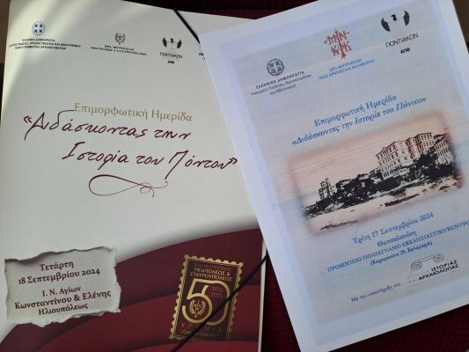
20-09-2024 Training Seminars on Teaching the History of Pontus (Thessaloniki, September 17 and 18, 2024)
On Tuesday, September 17, 2024, in Eastern Thessaloniki, and on Wednesday, September 18, 2024, in Western Thessaloniki, training seminars for secondary school teachers were held entitled “Teaching the History of Pontus.” The seminars were co-organized by the General Secretariat for Religious Affairs of the Ministry of Education, Religious Affairs and Sports, the Holy Metropolises of Nea Krini and Kalamaria and of Neapoli and Stavroupolis, the Chair of Pontic Studies of the Aristotle University of Thessaloniki, and the Directorates of Secondary Education of Eastern and Western Thessaloniki.
The Holy Metropolises warmly welcomed the educators in their hospitable venues, where participants had the opportunity to learn about and exchange views on historical and educational issues. Of particular interest were the in-depth presentations by university professors, associates of the Chair of Pontic Studies, and active educators on the history of Pontus and on the pedagogical use of the relevant textbook for teachers. This publication, issued by the General Secretariat for Religious Affairs in collaboration with the Chair of Pontic Studies of the Aristotle University of Thessaloniki and the Apostoliki Diakonia of the Church of Greece, will be a valuable resource for those wishing to delve into the history of Pontic Hellenism.
The participation and interest of the educational community serve as motivation for organizing similar events in the future, which will shed light on all aspects of the turbulent history of Pontus and provide the necessary material to raise students’ awareness of issues related to the genocides of the 20th century.

