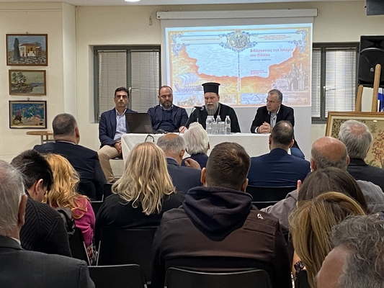
15-11-2024 “Teaching the History of Pontus” Book Presentation and Training Seminar (November 11 and 12, 2024)
On Monday, November 11, 2024, a presentation of the professor’s textbook entitled “Teaching the History of Pontus”, published by the General Secretariat for Religious Affairs of the Ministry of Education, Religious Affairs and Sports, in collaboration with the Chair of Pontic Studies of Aristotle University of Thessaloniki and the Apostoliki Diakonia of the Church of Greece, with the support of the Volos Academy for Theological Studies, was held at the Museum of Asia Minor Hellenism “Filio Chaidemenou”. This work serves as a valuable resource for those wishing to engage in the history of Pontic Hellenism and, in particular, for educators who wish to teach it.
After the guests were welcomed by the Vice President of the World Cultural Foundation of Hellenism of the Diaspora, Mr Konstantinos Tombouloglou, the event opened with a message from the Director General of the Apostoliki Diakonia of the Church of Greece, His Eminence Metropolitan of Fanari, Mr Agathangelos, followed by greetings by the Mayor of Nea Filadelfia, Mr Ioannis Tombouloglou, and the representative of the Volos Academy for Theological Studies, Mr Nikos Kouremenou. The publication was presented by His Eminence Metropolitan of Nea Ionia, Filadelfia, Irakleio and Chalkidona, Mr Gabriel; the Secretary General for Religious Affairs of the Ministry of Education, Religious Affairs and Sports, Mr George Kalantzis; and, on behalf of the textbook’s editorial team, Mr Kyriakos Chatzikyriakidis, Assistant Professor at the Chair of Pontic Studies of Aristotle University of Thessaloniki, and Mr Theodosios Kyriakidis, Research Associate at the Chair of Pontic Studies of Aristotle University of Thessaloniki .
On Tuesday, November 12, 2024, an educational training seminar entitled “Teaching the History of Pontus” for secondary school teachers was held at the welcoming venue of the Museum. The seminar was organized by the General Secretariat for Religious Affairs of the Ministry of Education, Religious Affairs and Sports, in cooperation with the Holy Metropolis of Nea Ionia, Filadelfia, Irakleio and Chalkidona and the Chair of Pontic Studies of Aristotle University of Thessaloniki.
Participants had the opportunity to learn about and exchange views on historical and educational issues, and take a guided tour of the Museum. Of particular interest were the in-depth presentations by university professors, associates of the Chair of Pontic Studies, and active educators, as well as the experiential workshops. The participation and interest of the educational community serve as motivation for organizing similar events in the future, which will shed light on all aspects of the turbulent history of Pontus and provide the necessary material to raise students’ awareness of issues related to the genocides of the 20th century.
The events were held with the support of the World Cultural Foundation of Hellenism of the Diaspora of the Municipality of Nea Filadelfia – Nea Chalkidona.

