12-07-2024 Training Program entitled “The Holocaust as a starting point – Beginners training, Albania–Greece dialogue”
The General Secretariat for Religious Affairs of the Ministry of Education, Religious Affairs and Sports, the French Mémorial de la Shoah Foundation, and the Albanian National Association of History Teachers “Youth and History,” with the support of the Jewish Museum of Greece, successfully co-organized a bilingual training program, in Greek and English, entitled “The Holocaust as a Starting point – Beginners training, Albania–Greece dialogue.”
The program, supported by the Jewish Museum of Greece and held in Ioannina from April 2 to 4, 2024 included historical lectures, discussions, and workshops with a total of 39 educators participating: 20 from Albania and 19 from Greece, from schools of Kozani, Zakynthos, Arta, and Ioannina.
Upon completion of the program, participants were asked to create and present a final lesson plan on the topic of the Holocaust.
The training program concluded with a guided tour for the participating teachers to the Zosimaia School of Ioannina, located in the historic building on Zosimadon Street, as well as the city’s Jewish Synagogue.
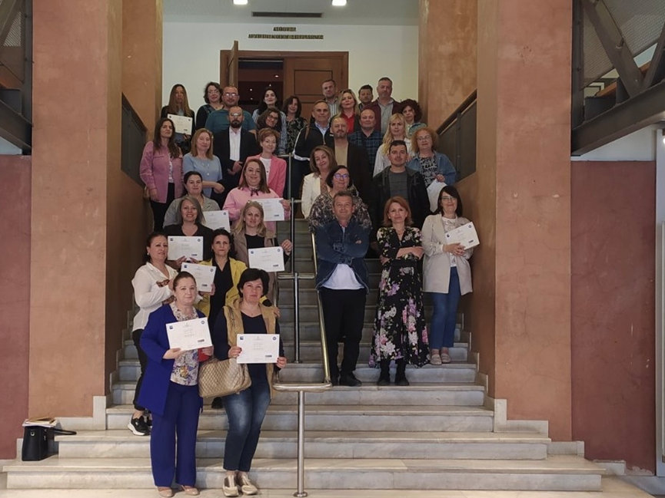
End of the Seminar- Certificates
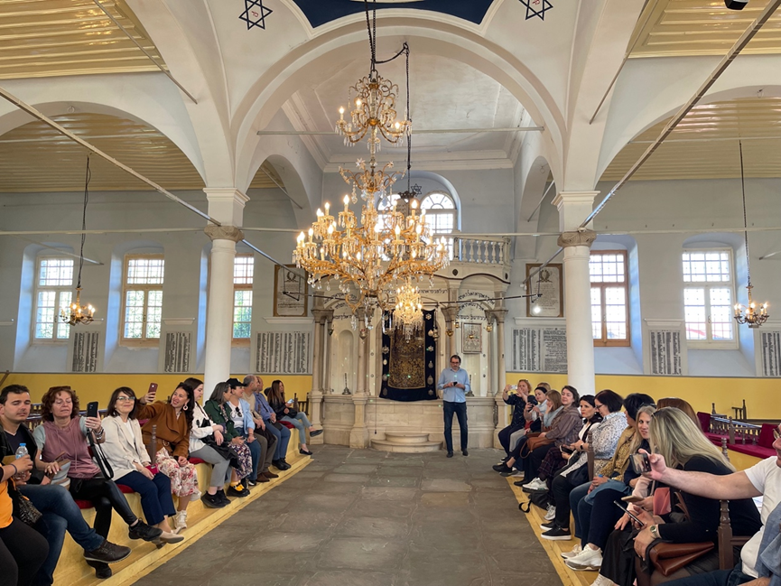
The educational visit to the Jewish Synagogue
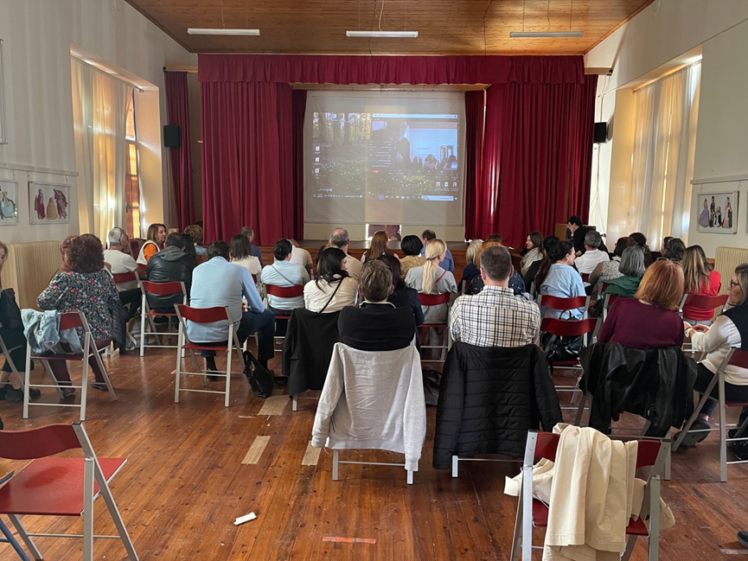
The educational visit to the Zosimaia School of Ioannina

