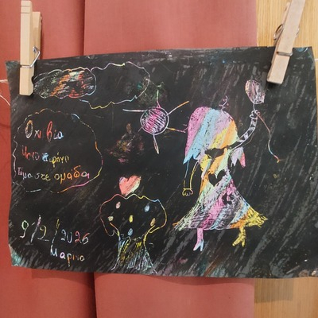
12-02-2026 Experiential Workshops titled: “Children seek and cultivate life values that protect them”
On Monday, February 9, and Tuesday, February 10, 2026, experiential workshops entitled “Children seek and cultivate life values that protect them” were held at the Ministry of Education, Religious Affairs and Sports. The workshops were addressed to fifth and sixth-grade elementary school students, students in all three grades of middle school, and first and second-year high school students from schools in Attica, as well as to their accompanying teachers.
This educational initiative was held for the third time at the Ministry of Education, Religious Affairs and Sports and is part of a series of initiatives organized under a Memorandum of Cooperation between the General Secretariat for Religious Affairs, the Ecumenical Forum of European Christian Women “Damaris the Athenian,” and the “Initiative for the Prevention of Domestic Violence” of the Youth and Family Foundation of the Holy Archdiocese of Athens. Among the key objectives of the Memorandum are the prevention and response to child abuse, both by adults and among minors.
During the workshops held on Monday, February 9, 146 pupils from six elementary schools in Attica participated, while on Tuesday, February 10, 188 pupils from six middle schools and three high schools in Attica took part.
The experiential workshops, tailored to the needs and characteristics of each educational level, were conducted by specialized facilitators from the fields of education, health promotion, theatre, visual arts, and sports, as well as by representatives of the Sub-Directorate for the Protection of Minors of the Hellenic Police of Attica. The thematic areas of the workshops focused on protection from uncontrolled internet access, artificial intelligence, raising awareness about child abuse, building healthy interpersonal relationships, athletic ideals as opposed to violence, as well as ways of prevention and protection against juvenile delinquency (Safe Youth & Panic Button).
At the same time, on both days, an experiential workshop was held for the accompanying teachers, focusing on teacher–student relationships and strengthening a supportive and safe school environment.
