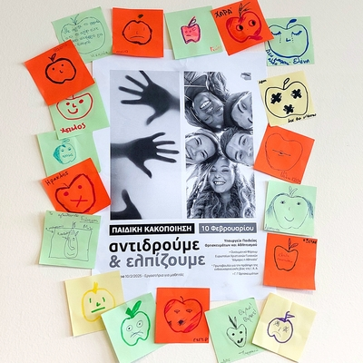

11-02-2025 Educational Program (10-02-2025) “Child Abuse: We React and We Hope”- Experiential Workshops
On Monday, February 10, 2025, the educational program entitled “Child Abuse: We React and We Hope” – Experiential Workshops, co-organized by the General Secretariat for Religious Affairs, the Ecumenical Forum of European Christian Women “Damaris the Athenian,” and the “Initiative for the Prevention of Domestic Violence” of the Youth and Family Foundation of the Holy Archdiocese of Athens, within the framework of the Memorandum of Cooperation dated September 4, 2024, between the aforementioned bodies was held for the second time at the Ministry of Education, Religious Affairs and Sports, with the aim to prevent and effectively address child abuse by adults and/or children.
Classes from 12 general and special education secondary schools from Attica and Evia with 279 students, along with their accompanying teachers, participated in the workshops.
The workshops were conducted by specialized facilitators from the fields of education, the Theatre of the Day, “The Smile of the Child,” the Greek Police’s Office for combating Domestic Violence, and the Sub-Directorate for the Protection of Minors of Attica.

