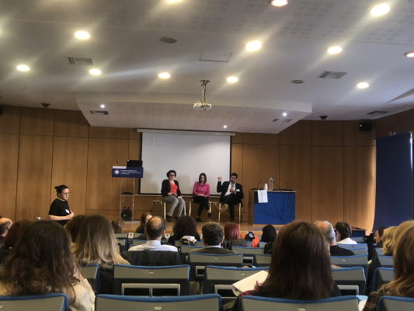
08-12-2023 Seminar on “Education against Anti-Semitism, Intolerance and Discrimination in Greece: Key Elements for Teacher Training” (December 4 and 5, 2023, Athens)
On December 4 and 5, 2023, a highly successful seminar on “Education against Anti-Semitism, intolerance and Discrimination in Greece: Key elements for teacher training” was held in the “Galateia Saranti” hall of the Ministry of Education, Religious Affairs and Sports in Athens. The seminar was co-organized by the General Secretariat for Religious Affairs of the Ministry, UNESCO, the OSCE Office for Democratic Institutions and Human Rights (ODIHR), and the Jewish Museum of Greece.
The event was addressed by:
- Mr George Kalantzis, Secretary General for Religious Affairs of the Ministry of Education, Religious Affairs and Sports;
- Mr David Saltiel, President of the Central Jewish Council of Greece;
- Ms Katharina von Schnurbein, European Commission Coordinator on combating Anti-Semitism and promoting Jewish life (online);
- Ms Chryssoula Aleiferi, Ambassador, Special Envoy of the Ministry of Foreign Affairs for combating Anti-Semitism and preserving the memory of the Holocaust; and
- Ms Heather Mann, Associate Project Officer in UNESCO’s Section of Education for Global Citizenship and Peace.
The seminar was attended by academics, primary and secondary education officials, in-service teachers, and representatives of Jewish communities.
In a creative atmosphere, participants were informed, exchanged views, and enriched their professional resources with material useful for educational practices that will help combat Ant-Semitism, intolerance, and discrimination, which threaten social cohesion.

