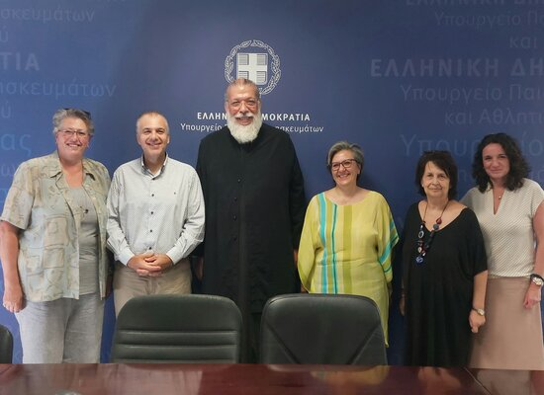

05-09-24 “Signing of a Memorandum of Cooperation for the Prevention of violence and abuse against women, children, and adolescents”
A Memorandum of Cooperation on the prevention of violence and abuse against women, raising of awareness regarding gender-based and all forms of violence, the prevention and response to children and adolescent abuse, and raising their awareness concerning the prevention and response to all forms of abuse was signed on Wednesday, September 4, 2024, at a special ceremony at the Ministry of Education, Religious Affairs, and Sports.
The Memorandum was signed between the General Secretariat for Religious Affairs of the Ministry of Education, Religious Affairs, and Sports, the Youth and Family Foundation of the Holy Archdiocese of Athens, under the framework of the program “Initiative for the Prevention of Domestic Violence,” and the Ecumenical Forum of European Christian Women “Damaris the Athenian.”
The Memorandum provides for the implementation of actions aimed at raising students’ understanding of various forms of violence and abuse, as well as the implementation of educational programs through innovative activities that actively engage participants.
On behalf of the Ministry of Education, Religious Affairs, and Sports, the Memorandum was signed by the Secretary General for Religious Affairs, Mr. George Kalantzis; on behalf of the Youth and Family Foundation of the Holy Archdiocese of Athens, by the Coordinator of the program “Initiative for the Prevention of Domestic Violence,” Protopresbyter Mr. Antonios Kalligeris, and on behalf of the Ecumenical Forum of European Christian Women “Damaris the Athenian,” by the Co-President of the Greek Section, Ms. Maria Sik.

