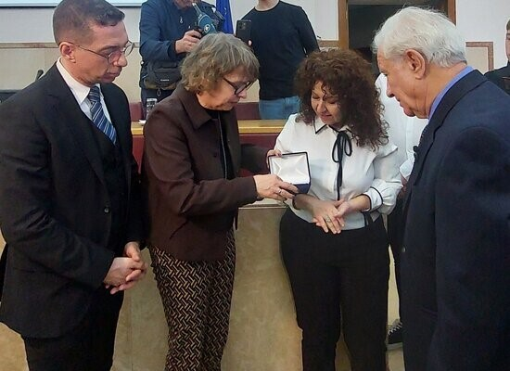
05-02-2026 Arolsen Archives’ #StolenMemory International Campaign: Return of Personal Belongings of a Greek Prisoner of a Nazi Concentration Camp
The Arolsen Archives’ international #StolenMemory campaign (Arolsen Archives- International Center on Nazi Persecution) aims to return the personal belongings of prisoners held in concentration and forced labor camps to their rightful owners or their descendants.
In this context, the educational initiative #StolenMemory of the Arolsen Archives is being implemented for the second consecutive school year, in cooperation between the General Secretariat for Religious Affairs of the Ministry of Education, Religious Affairs and Sports and the Diplomatic and Historical Archives Service of the Ministry of Foreign Affairs. Groups of students from middle and high schools across the country are participating in the initiative, with the goal of locating relatives of Greek prisoners and returning their ancestors’ personal belongings. During the previous school year, the relatives of two Greek prisoners, Theofilos Symeonidis and George Hanas, were successfully located and received their family heirlooms.
On Monday, February 2, 2026, a ceremony was held in Thessaloniki to return the personal belongings of Christos Taktikos, a Greek prisoner in the Nazi concentration camp Neuengamme, to his son, Antonios Taktikos.
In an emotionally charged atmosphere in the lecture hall of the Society for Macedonian Studies, Mr. Antonios Taktikos received his father’s two preserved rings from Dr. Anke Münster, Head of Public Relations at the Arolsen Archives. Mr. Taktikos was located following a successful research by a group of students from the Neochori High School of Arta.
The event was addressed by the President of the Society for Macedonian Studies, Mr. Vasileios Pappas, who, among other things, emphasized that by returning these heirlooms not only the personal history of Christos Taktikos but also the collective historical memory of Thessaloniki is honored in a meaningful way.
Dr. Anke Münster briefly presented the work of the Arolsen Archives and the international #StolenMemory campaign, expressing her enthusiasm for the schools’ participation in the campaign and for the high-quality work carried out by the students of the Neochori High School of Arta.
The Secretary General for Religious Affairs, Mr. George Kalantzis, in a message delivered through the Director of his Office, Ms. Vasiliki Keramida, thanked the teachers, students, and all those who contributed to the successful outcome of the initiative. He also emphasized the importance of this innovative educational program, which strengthens the historical consciousness of the educational community, ensuring that memory remains alive not as a distant past but as a foundation for the future.
The President of the Central Board of Jewish Communities in Greece, Mr. David Saltiel, attended the event and noted that every preserved exhibit sheds light on the reality of the complete dehumanization of people that formed the basis of Nazi criminal practices.
Mr. George Polydorakis, Ambassador at Large, First Counselor, and Head of the Diplomatic and Historical Archives Service of the Ministry of Foreign Affairs, among other things, described the educational initiative #StolenMemory of the Arolsen Archives as one of the most important cooperation programs between his Service and the General Secretariat for Religious Affairs of the Ministry of Education, Religious Affairs and Sports.
Then, the principal of the Neochori High School of Arta, Ms. Katerina Antoniou, together with teacher Ms. Eleftheria Griva and their group of students, presented to the audience the stages of their research that led to the successful identification of Mr. Antonios Taktikos, highlighting the educational value of the program and the experiential approach to history.
In closing, Mr. Antonios Taktikos, visibly moved, received his father’s personal belongings from Dr. Anke Münster and then warmly thanked all those who contributed to the initiative’s success. As he noted, the students and teachers of the Neochori High school of Arta gave him an unexpected life experience, as, after decades, through these heirlooms, “it was as if he saw his father.”
