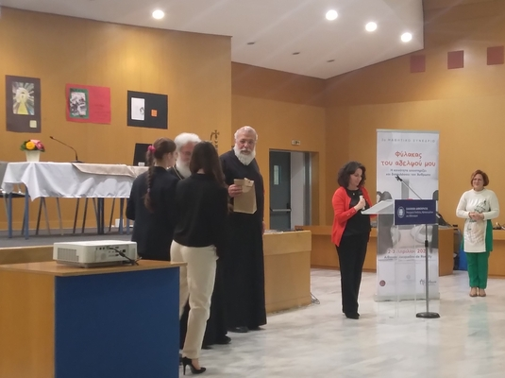
04-04-2025 Student Conference “Guardian of My Brother. The Community Supports and Protects Humanity” (2 & 3 April 2025)
On Wednesday, April 2, and Thursday, April 3, 2025, the student conference entitled “Guardian of My Brother. The Community Supports and Protects Humanity”, which was co-organized for the second consecutive year by the “Initiative for the Prevention of Domestic Violence” of the Youth and Family Foundation of the Holy Archdiocese of Athens and the General Secretariat for Religious Affairs was successfully held at the Ministry of Education, Religious Affairs and Sports. .
Approximately three hundred (300) students from the 2nd and 3rd grades of middle school and the 1st and 2nd grades of high school, from school units under the Regional Directorate of Primary and Secondary Education of Attica, participated in the conference, accompanied by their teachers.
The students participated either as attendees and/or as speakers, presenting a written essay or creating a poster.
The General Secretariat for Religious Affairs congratulates the students who took part in the conference, their teachers for their guidance, and, especially, the parents of the students.
