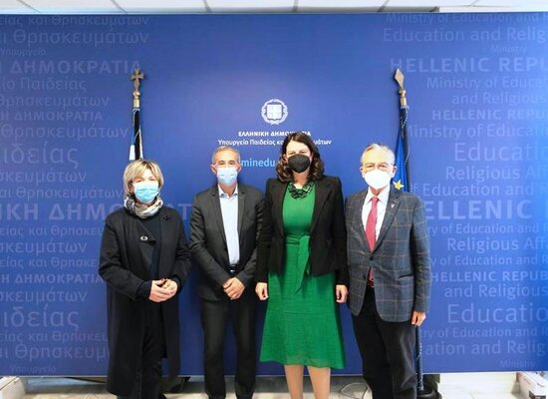
In the photo, from left: Anna Missirian, President of the MOHA Research Center; Jacques Fredj, Director of the French Foundation Mémorial de la Shoah; Niki Kerameus, Minister of Education and Religious Affairs; and Makis Matsas, President of the Jewish Museum of Greece.
03-02-22 Memorandum of Cooperation for the teaching of the Holocaust
A Memorandum of Cooperation was signed between the Minister of Education and Religious Affairs, Niki Kerameus, the Director of the French Foundation Mémorial de la Shoah, Jacques Fredj, the President of the Jewish Museum of Greece, Makis Matsas, and the President of the MOHA Research Center, Anna Missirian.
The purpose of the Memorandum is to strengthen and establish a solid foundation for the implementation of activities and seminars for educators and students, focusing primarily on genocides and the Holocaust. Among other things, the contracting parties will organize training programs for teachers, students, and society on the genocides of the twentieth century, while the possibility of educational programs on the Holocaust will also be explored for education professionals, as well as broader public or other interested bodies.
During the signing ceremony, Minister Niki Kerameus thanked the representatives of the organizations, emphasizing the importance the Ministry of Education and Religious Affairs places on Holocaust and Genocide education, especially at a time when we are, unfortunately, witnessing the outbreak of armed conflicts on European soil, evoking memories of some of the darkest chapters of our history.
The Minister referred to the successful completion of Greece’s Presidency of the International Holocaust Remembrance Alliance (IHRA), during which a wide range of educational and awareness-raising activities were organized, while committed to continue collaborations in the same direction under the framework of the new Memorandum of Cooperation. The stated goal of Greece’s IHRA Presidency, besides, was: “Teaching and Learning about the Holocaust.”
Jacques Fredj, Director of the French Foundation Mémorial de la Shoah, emphasized that the cause of genocides is none other than intolerance and marginalization, together with the deterioration of democratic values and the subsequent undermining of the democratic system. Therefore, as genocides do not begin suddenly, it is our duty to continuously cultivate democratic education and dialogue with everyone, which underscores the importance of Holocaust educational programs. Special attention must be given to promoting tolerance, freedom, and democracy, while being alert to the rise of antisemitism.
Makis Matsas, President of the Jewish Museum of Greece, thanked for the continuation and further strengthening and deepening of the existing cooperation with the Ministry, particularly with the General Secretariat for Religious Affairs, emphasizing that the goal is shared: the preservation of memory in order to prevent any possibility of new genocides or the Holocaust. This is a positive outcome that all humanity needs.
Anna Missirian, President of the MOHA Research Center, also thanked all contracting parties for their collaboration, welcoming its expansion and further consolidation.
The signing ceremony at the Ministry of Education and Religious Affairs was also attended by Mr. George Kalantzis, Secretary General for Religious Affairs; Yossi Amrani, Ambassador of Israel to Greece; David Saltiel, President, and Viktor Eliezer, Secretary General of the Central Jewish Council in Greece; Janet Battinou, Director of the Jewish Museum of Greece; representatives of the German and French Embassies, as well as academics and history experts.
The Minister warmly thanked all participants and in particular the General Secretariat for Religious Affairs and its head, George Kalantzis, for their tireless efforts and systematic work, both in education on the Holocaust and Genocides and in actions promoting religious freedom and fostering interfaith relations.

