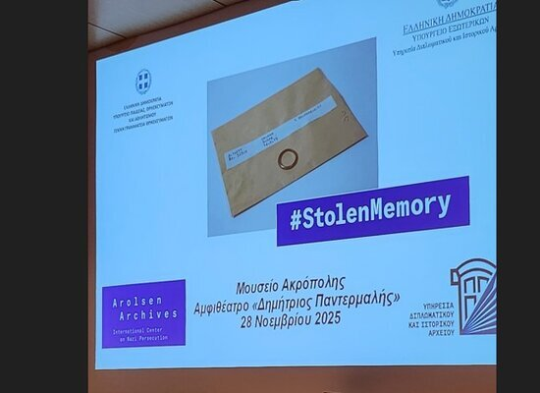

02-12-2025 Presentation of the Arolsen Archives’ #StolenMemory Campaign and Its Results in Greece
The Diplomatic and Historical Archives Service of the Ministry of Foreign Affairs and the General Secretariat for Religious Affairs of the Ministry of Education, Religious Affairs and Sports organized a particularly moving event on Friday, November 28, 2025, at the “Dimitrios Pantermalis” Auditorium of the Acropolis Museum, to present the #StolenMemory campaign of the Arolsen Archives and its results in Greece.
The campaign aims to trace the families of victims of Nazi persecution whose personal belongings were found in Nazi concentration camps and forced labor camps and transferred to the Arolsen Archives after World War II, and to return these items to them.
During the event, three schools presented their project, in which they identified the families of three Greek victims of Nazi atrocities. A particularly moving moment was the return of a personal item belonging to George Chanas, a Greek prisoner in a concentration camp, to a relative, after his family was located by students of the Evening Vocational High School of Evosmos, Thessaloniki. The program also included the screening of audiovisual material created by students and teachers as part of the search for relatives of Greek prisoners, whose personal belongings are held in the Arolsen Archives.
At the event, Prime Minister, Kyriakos Mitsotakis, was represented by Mr. Giannis Papadomarkakis, Secretary General for Primary, Secondary and Special Education of the Ministry of Education, Religious Affairs and Sports. His Beatitude Archbishop of Athens and All Greece, Mr. Ieronymos, was represented by His Grace Bishop of Talantio, Mr. Theologos, who read a message from the Archbishop. A greeting was delivered by the Head of the Diplomatic and Historical Archives Service of the Ministry of Foreign Affairs and Greece’s Representative to the International Commission for the Arolsen Archives, Expert Ambassador-Counsellor Mr. George Polydorakis, while a message was read on behalf of the Secretary General for Religious Affairs, Mr. George Kalantzis.
The #StolenMemory campaign continues, honoring the memory of Greek victims of Nazi persecution and highlighting the importance of historical memory, education, and the protection of history from oblivion and distortion.
